**ANNUAL REPORT-2013-2014**

**ECOVIC**

**(Environmental Consultancy Vikash Centre )**

STRUCTURE OF ECOVIC

(Organization Organagrame)

General Secretary

Governing Body Executive Director,

Executive Director, General Secretary

Monitoring Cell

Advisory Board G.S cum P.D

Financial Advisor

Field Officer

Director Administration

Chief Accountant

Project Staff

Project Accountants

Project Asst. & Other

Full time & Part time staffs and other staffs

Field Staff

Teacher &Volunteers

**From the Desk of General Secretary**

*We take the privilege once again to present Annual Activity Report of ECOVIC for the year 2013-14 before all the concerned persons of the organizations associated as partners and well wishers of our organization. It is worth mentioning that our organization has worked throughout the year with added dedication and motivation. The organization is committed to reach and serve the most unprivileged and deprived section of the society. The organization has scaled up and strengthened most of the ongoing activities with lots of achievements. The important issues addressed by the organization during this year were on street children,Old Age Person .Health and Hygiene ,HIV/AIDS and Women Empowerment, Child Rights and Child Education and other socio-economic* development *activities to promote holistic development with active participation and involvement of the community. Outcome of all the intervention has been very encouraging and it has motivated us further to intensify our efforts to address added local issues and problems with great vigor. The organization has experienced a lot and has built good rapport with the community in addressing most of the issues and problems and has also been recognized by many others in the events of its deeds.*

*I express my heartiest thanks and best regards to the district administrations, Government agencies, donors and partner agencies, to our members of the Executive Committee & General Body, friends, sympathizers , our team of social workers, who have been supporting ECOVIC and all well wishes for their cooperation, guidance and support without which we would not have been able to achieve our organizational vision, mission and objectives.*

*I would also put on record of my appreciation to all our staff and volunteers for their tireless effort in*

*making our dream a reality.*



**Location of Head Office:**

It is about 5km east of Patna Railway station, Bus stand and Airport at 278, Nehru Nagar, Patliputra Colony, Patna – 13.

**About Organization**

Ecovic is a Non Profit organization registered under society’s registration Act 21, 1860, under FCRA, 80G, and 12A of Income tax Act 1961. Ecovic has a group of social worker, doctors, educationalist and engineers of tremendous vision. Our grass root workers and animators are reaching on the door steps of under privileged and unnerved people to help them. Thousand of people are supporting us with their precious views, vision and ideas. We take pledge to serve the Common mass

**Goal** - To generate awareness, consciousness and promote holistic development of all sections of the society.

**Vision** - The organization has a vision to have equity based society bereft of any exploitation on the ground of sex, race, caste, creed, class and religion.

**Mission** - To strive for the sustainable development process and improvement inquality of life of all sections of the society with emphasis on deprived and marginalized through participatory approach and also empower them to avail their rights.

**ORGANIZATIONAL VALUES**

1. Accountable with Transparency – We pursue the highest standard of accountability to the community as well as to the agencies for which we are working in partnership. We are accountable with regard to management of financial and non financial resources, programmes and the people. Our work and functions has been visible for its partners and community for whom we are working.
2. Inclusive and Equitable – We strongly believe that in the development process many people have been left behind. The development process is incomplete until and unless benefit of development reaches to the last persons in the community. We have always been sensitive and committed to reduce all forms of discrimination with focus on deprived and marginalized sections of the society.
3. Democratic – Our organization respects the democratic value and it is deep rooted from top to bottom. It reflects in the decision making process and framing the policies for the organization where every view is taken into considerations.
4. Collaborative – Our organization has always shown willingness to collaborate with any agencies at the regional, national or international level who are working for the development of the society or community.
5. Pro-Active – Our organization has shown willingness and has always responded to serve the community during man-made or natural disaster. It has always stood by the side of the community during these difficult periods irrespective of sex, race, caste, creed, class and religion.

Ecovic believes in co-existence philosophy. Hence we have a strong humanitarian approach. We believe in a society where every individual can get his or her share. Ecovic To strive for the sustainable development process and improvement inquality of life of all sections of the society with emphasis on deprived and marginalized through participatory approach and also empower them to avail their rights.

1.To provide basic education to Children, women, farm laborers Neo-literates.

2. Reproductive and child health Programmes.

3. To advocate, campaign, promotion of women and child rights.

4. To provide services & Special School for Speech and Hearing Impaired Children

5. Advocating human rights issues.

6. Special School for Child Labour

Our Mission statement is “Transformational development of the people through participatory practices on sustained basis” We need much financial support for other operations. We are communicating with various donors too.

Our Officials, members and grass root level volunteers are working very hard to give a new space to the project area on all fronts-socio-economic and other social parameters.

Our grass root workers and animators are reaching on the door stapes of under privileged and unnerved people to help them out at any time working with the Organization

Thousand of people are supporting our views, vision and mission. We take a pledge to serve the common mass

**JAGRITI DRUG DE-ADDICTION CUM REHABILIATION CENTRE, MOHANIA, KAIMUR**

It is about 180 km west of Patna and connected by N.H.30 & G.T.Road and railway station namely Bhabhua Road, Mohania.

Ecovic used to conduct various types of activities for social upliftment in the field of drug abuse, disable, education, health, and HIV/AIDS.

A 15 bedded Integrated Rehabilitation Centre for Addicts at Mohania in the Kaimur district is in operation for the last sixteen years with funded by ministry of Social Justice & empowerment, Govt. of India.

Majority of Youths of this district are generally habituated in taking various types of drugs it has been revealed that a quite excessive number of young persons is drug addicted in the surrounding Kaimur, district. This centre very relief for family members and society.

During the year 2013-2014 centre has treated the 186 persons. Center has organized 20 out reach programmes. Staffs of Jagriti visited on 353 ex-client in this year and 969 houses visited this year.

Nine of relapse cases and five clients are dropped out during the year. Total number 1134 individual counseling , 841 family counseling and 347 group counseling during the year. The Awareness programme has been arranged to get rid of deadly drug / HIV through banners, exhibition, pamphlets, loudspeaker and seminar.

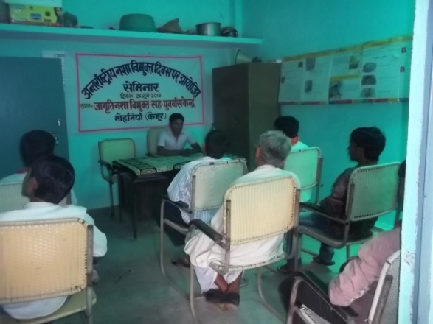

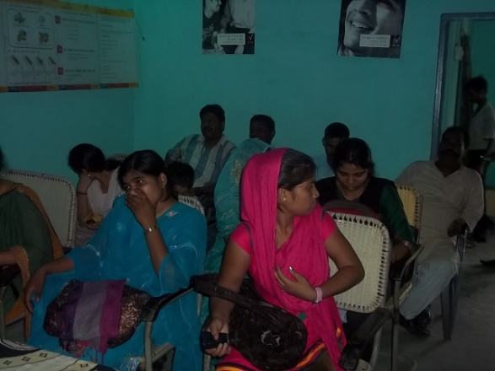

The organisation has arranged Seminar on an international drugs day 26th June2013 at Mohania inviting the local government staffs, respectable persons of neighboring area and the delay drugs and used to arrange seminar along with family of drugs addict society and individuals. They should be vigilant to fight against the habit to becoming drug addict.

Such programme have also been organized on No-Tobacco day to entertain treated persons along with family member society and try to make team alert to fight against this evil.

The Jagriti Integrated Rehabilitation Centre for Addicts is providing counseling treatment and rehabilitation to affected persons. The center is very popular among local people and functioning very well.

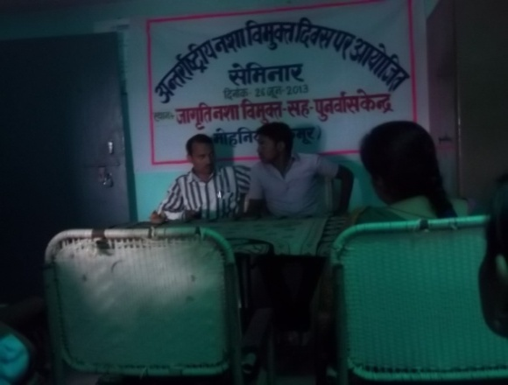

Those persons who are getting treatment at the centre, they are getting due respect in the family and society of the people in general. Though there is arrangement from the centre as well to advise the treated persons from time to time to remain alert of not becoming drug addict again in future. The centre used to remain in contact or Home Visit with treated

persons. The Jagriti is always getting cooperation from a family of treated persons and society as a whole. The counseling work is continuing even after the treatment of drug addict persons from time to time. District authority and police station of this district are also supporting this center.

Other branch of center are Targeted Intervention programme (HIV/AIDS) for IDUs in Mohania. Human resource is wonderful resource and everything is possible to achieve as a sustainable development of human resource with balance living.

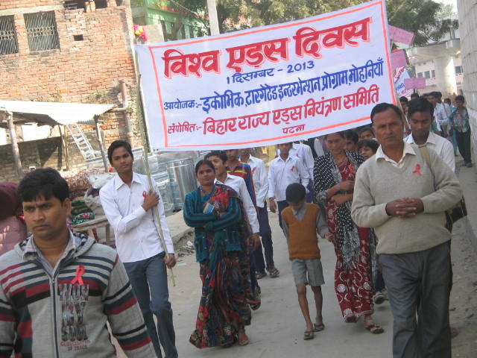

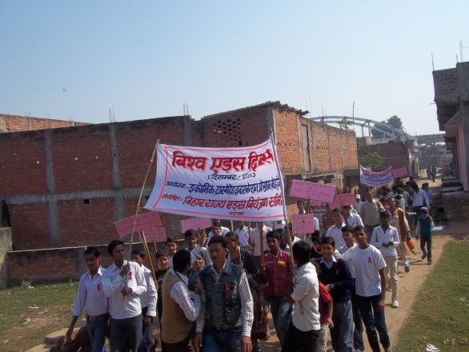

**TARGETED INTERVENTION**

**Sponsored by Bihar State AIDs Control Society,**

Bihar is sitting on the time bomb of AIDS epidemic. It is revealed by recent surveys which show that the HIV prevalence rate in Bihar is about five times higher than what was believed to be and Bihar is in grip of HIV epidemic. The survey conducted by Bihar State AIDS control society in all 38 districts in July 2005 and December 2005 have found the rate to be 0.53%.Most of the people detected are in the age-group of 25 to 45 years and its increasing every yea.

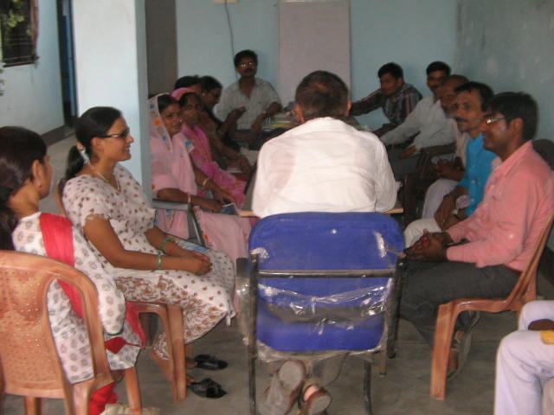

The situation is alarming as Bihar is one amongst the poorest states in the country and hence among the biggest suppliers of migrant laborers.Whether it is seasonal farm hands for Punjab or construction workers for the skyscrapers in Mumbai and Delhi or new suburbs the daily wagers are supplied by Bihar.

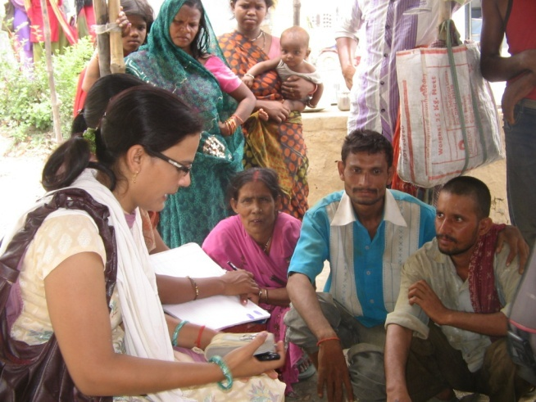

Keeping in view NACO and BSACS have taken stern action to curb the epidemics in different districts of Bihar and in Mohania (Bhabua Distt.) the responsibility has been given to **ECOVIC** for the prevention of HIV/AIDS.

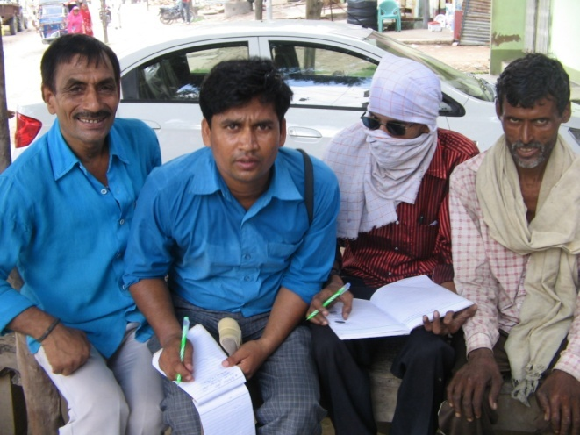

**Targeted Intervention Project has been implemented in Kaimur during the financial Year 2013-14 to strengthen service delivery mechanism and enhance the quality of life of HRG (High Risk Group) population. Various activities have been worked out during the project period for prevention of HIV infection, reduction of risk of epidemics and create awareness about it.**

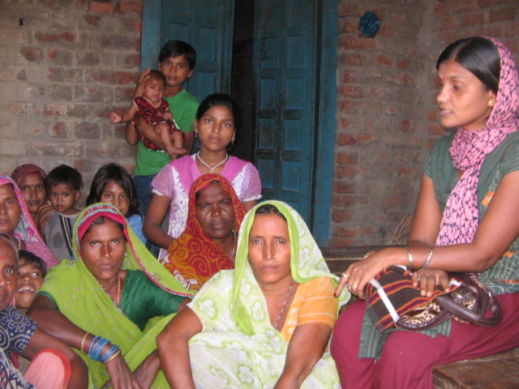

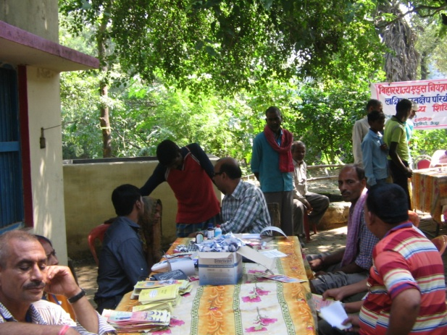

**The main goal of TI Project is to Reduce (Minimize) HIV Infection among HRG Population (IDUs, FSW).**

**ACTIVITIES CARRIED OUT**

Various activities have been done by the project staffs during the period in the working area.

During the project period these were the following main activities.

* Coverage of HRG Population, identification and new registration.
* Behaviour Change Communication (BCC) for adopting safer practices.
* Needle Syringe Exchange Programme (NSEP) for reduction the risk of HIV Infection.
* Free Condom Distribution to the community.
* Advocacy, Crisis Management and awareness meetings were conducted to enhance smooth service delivery mechanism.
* Health Camp organized for screening the STD/STI among the HRG Population.
* Awareness Camp, Community Event and AIDS Day Rally were organized for creating awareness among populations about epidemics.

Strengthen Linkages and service delivery mechanism for providing better health facilities.

HIV Testing, referrals and linkages with other service providers and stakeholders. were done to strengthen service delivery.

**ACHIEVEMENTS**

Following are the main achievements for the project during the period 2013-2014

**Services Provided for IDUs. And FSW..**

|  |  |  |  |
| --- | --- | --- | --- |
| **Name of Activities** | **Referrals**  **IDUs/ FSW** | **IDUs** | **FSW** |
| **HIV test** | 752/140 | 632 | 98 |
| **Syphilis Screening** | 133/66 | 62 | 40 |
| **DOTS** | 16/06 | 16 | 6 |
|  | | | |
| **Name of Activities** | Number of Meetings | IDUs | FSW |
| **Counseling** |  | 1480 | 486 |
| **DIC Meeting** |  | 11 | 09 |
| **Hot Spot Meeting** |  | 118 | 33 |
| **Crisis Meeting** |  | 22 | 03 |
|  | | | |
| **STI Treatment** |  | 276 | 138 |
| **HIV +Ve Found** |  | 09 | 02 |
| **Advocacy Meeting**  **With stake holders** | 20 | | |
| **Health Camp** | Ramgarh | | |
| **Community Event** | 2 | | |

**SAMARTH (CENTRE BASED SCHEME**)

It is located in Gaya town. It is about 5km from Gaya Railway station and about 100 km from state Capital city, connected by road and railway.

The organization is registered with National Trust, Govt of India. Under this programme , services provided to disabled children in both way, long term(Prolonged stay) and short term (Respite care) for mentally retarded of every age group. The 24 numbers of prolonged stay during the year and 34 number of respites can stay during the year. Total number of stay is 58 (Prolonged and Respites)

Those persons and parents who are getting treatment at the centre, are duly respect in the family and in the society as well.There is a arrangement from the centre to advice the benefited persons to visit every fortnight. The centre is always getting cooperation from the family of desirable persons and by the society and a whole.

**Hridaya Project**

**Sponsored by Ministry of foreign affairs.Govt. of Netherland through India HIV/AIDS Alliance**

**Hridaya Services:**

*A) Direct Support*

PLHIV Emergency, Peer Progression, Crisis Response, Medical Support & Life Saving support.

*B) Education*

Hepatitis, Overdose, Legal Right, Family Meetings, SRH, Support Group Meeting, Positive Prevention.

*C) Referrals*

Detoxification, Nutrition, Social Entitlements, Hepatitis, SRH Services, CD4 testing, OST follow up,For spouses, ICTC/Pre ART, STI Management & Tuberculosis.

This projects is combined with Targeted intervention project (TI) for IDUs.Under this project we work for the families of those people who are involved in taking drugs through syringe and also we help them in getting the facilities by the Govt, institutions through aor linkages programmes,

We work for the Social entitlement of the IDUs so far 27 families have been covered under which help them to get Red Cars,Ration Card and caste certificate etc . and two widows pension is under process.

We also help IDUs who are taking drugs by sending themn to Drug de-Addiction centre to get rid of drugs restart their normal life.So far we have achieved to get 11 IDUs to get rid of Drugs completely and such persons under peer progression there is provision of Rs. 2000/- to assist them in repairing or modification of their earning equipments which will ultimately help their families

.

Under peer progression 4 people have been helped to repair their Pan Gumti Thela,Vegetable Thela.

We also work for those people who are HIV/Aids Patient and we provide a sum of Rs. 500 as Ration support once in a three month.Till now 9 such families have been provided the support.

So far 500 IDUs families have been registered under Hridaya Project and there is a provision of preventive training on SRH (Sexual reproductive health),prevention of Hepatitis C and prevention of overdose management etc to the IDUs families and we are providing that.

47 IDUs wives have been examined free of cost for HIV test and 37 wives for TB Test and 11 people have been provided the services of OST centre.

**Special School for Hearing Impaired and Mentally Retarded**

Location of the Special School for Hearing Impaired and Mentally Retarded is about 100 Km away from Patna and connected to Patna through patna- Bodhgaya road. It is about 3 km from Gaya railway station. This centre is providing comprehensive services through its experts to the Hearing Impaired and Mentally Retarded children. Total strength of Hearing Impaired and Mentally Retarded children in the school in this year 2013.14 is 70. In this school students are divided into different group according to their I.Q level, ability, reading writing skill. We provide the language development, Speech therapy, vocational training. Time to time assessment of the children with formal check list always carried out. We trained them through class room amplification as well as individual amplification device.. We trained them in daily living skill. The outcome of these facilities and services is really very positive.

**SPECIAL SCHOOL FOR CHILD LABOUR AT PATNA & GAYA**

**Sponsored by NCLP**

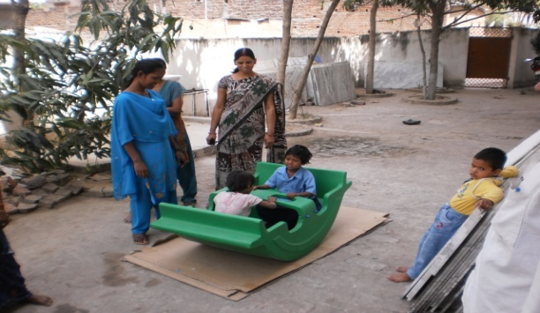Organization is running altogether **11** Special School for Child Labour at Patna and **Gaya.**

There are seven Child Labour Schhol at Patna and four school at Gaya with a strength of 50 children at each school.

This programme is supported by National Child Labour Project (NCLP) under The Ministry of Labour , Govt. of India.

All the Children belonging to the age group of 8 to 14 years. After reaching the age 14 they are admitted to another primary school likely and this is a continuous process. The organization is giving the vocational training in each school premises and also the provision of 150 Rupees stipend for every children and this amount is deposited in post office / Bank in name of Children.

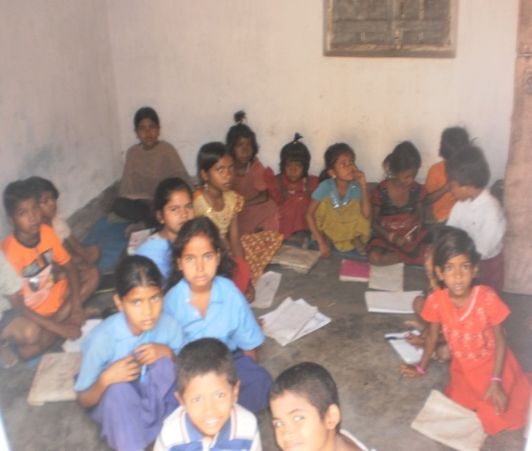

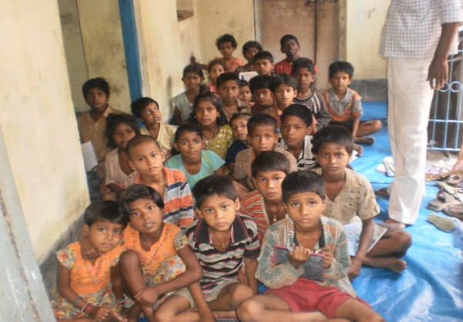

We are providing skill development training to these children, as well as language development which in course helping their self confidence. We focus on their Education, Vocational training, and regular medical checkup also.

**OPEN SHELTER FOR STREET CHILDREN**

**Sponsored by Department of Social Welfare**

Open Shelter at Kharkhura, Delha, Gaya Which is run by ECOVIC was established on 6th June 2013. is sponsored by Directorate of Social Welfare , Govt. of Bihar.

The main Purpose for establishing this Shelter is to take care of destitute, orphaned, run away children, rag pickers, migrated children etc. of Gaya district.

These kind of children are mainly found in

crowded area like railway station, Bus stand, Temple area and market area etc.

In our Shelter there are eight member of staff to help the purpose of the shelter home . Including one programme Coordinator, one Social worker, three ORW , two caregiver and one cook . ORW working at different transit point which is also the most probable place to get these kind of Children.

Our Coordinator and Social worker meet them personally, motivate them do their counseling to take them out of the vulnerable situation and bring them to the Shelter where all kinds of facilities are available for them like Food, Entertainment, Game, Computer education, Medical Aid and very good arrangement of beds in the neat and clean room where they can sleep.

We are working under the guidance of SCPS Bihar. The enrollment ,counseling ,history of such children and follow up are not only maintained into different registers but also we are maintaining online data by sharing our daily, quarterly and monthly reports with SCPS (State Child Protection Society) on regular basis.

SCPS not only monitoring this project but at the same time they are helping us always in positive manner whenever we need them.

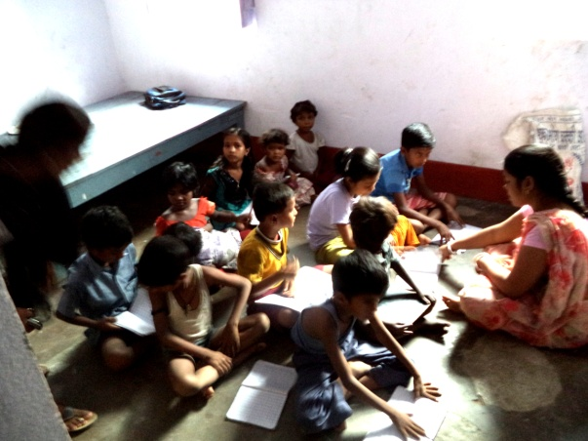

Study Room

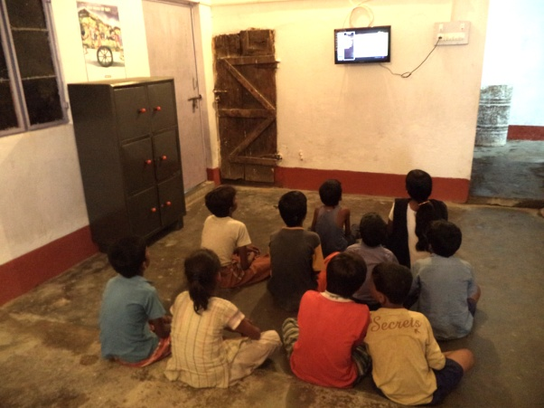

**Children watching TV**

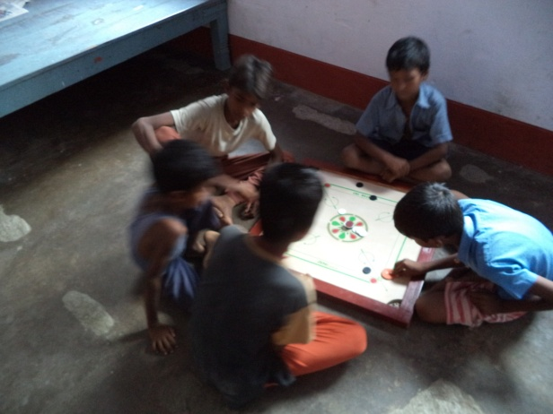

**Indoor Game**

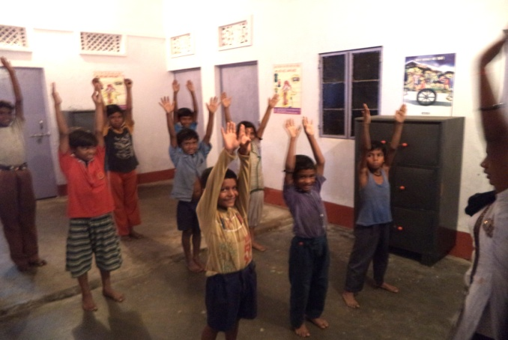 **Exercise**

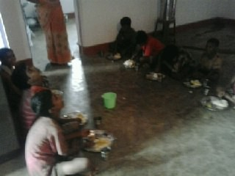

**Children having food**

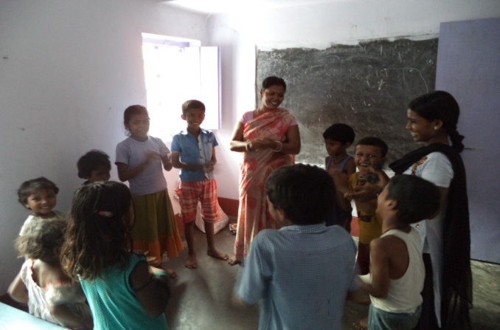 **Group Counseling**

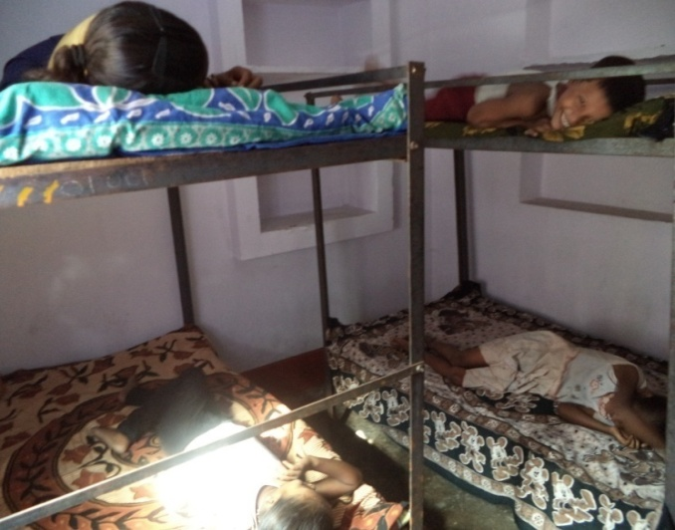

**One of the Sleeping Room**

There is facility of bridge education which you can say age appropriate education in playful environment.

The basic idea is to take them out of the vulnerable situation which is very dangerous. It has been that they are

indulge in all winds of socially deviant activities like drugs, gang war and sorry to say that some of them are getting sexually abused also. These are the children who really need care and we are working very hard to take them away from their vulnerable situation to our shelter and make them feel protected. We are giving them family like atmosphere and see to it that they don’t go back to their old habitat again.

CWC, Gaya has also major role as most of the time we report to them about every single child who come to our Shelter and then whatever the instruction come from CWC we follow them.

Apart from taking good care of them with love and affection we have reunited few of them to their families.

Since 6th June 2013 to 31th March 2014 our achievement are as follows:

* Total 84 number of such children have been enrolled to our Shelter
* Out of 84 children 14 children have been reunited to their families through us.
* Out of 84 children 58 children was Produced before the CWC and rest are regular Railway Platform children.
* Out of 84 Children following are the categories of children who have been registered in ECOVIC Open Shelter for Street Children
* Street Children - 18
* Rag Pickers - 26
* Beggers - 19
* Trafficked children - 02
* Street Performer - -02
* Small vendor -13
* Run away children - 01

**OLD AGE WELFARE PROGRAMME**

Care and Support for the old aged persons to lead a dignified and respectful life in the family and Society is the core objective of this program. The care for the old people is the need of the hour because it has been seen that that there is deterioration in our society and the most victim is the old age people who are getting detached or thrown out by the family members for so many reasons. These people are considered to be non-productive for their family and can bear no monetary gain to the family..Nutritional support and provision of daily usage materials: These old age people are rather dependent on the family for survival and some of them are left alone on the mercy of the community. They are excluded from their family and live in miserable condition. To help and support them, the organization provides them with nutritional support and has tried to make them feel happy and comfortable at the centre.

The institution is taking care of 50 old aged persons especially to provide necessary day care facility at HO/BO centre. Institution has also conducted counseling session to these persons and their caregivers. And every month organization has organized medical camp in each panchayat.To monitor the health of these people regular health check-ups are done and medicines are provided free of cost to them.

Finally Govt. has also found the necessity of a safe house for these deprived and needy people who has

now no one to take care .In the year 2014 our organization has got this Project SAHARA for old age people at Gaya which is going to start most probably in the month of August 2014.

**VOCATIONAL TRAINING**

Our organization also has made provisions of imparting vocational training like sewing and tailoring to these students to enhance their technical skills. These trainings would help them to be self dependent. Vocational training provides opportunity to these adolescent who have been deprived of formal education during their childhood and are now supporting their families with their income.

Unemployment is one of the core issue in the Project area and is a great concern for us in the development of the society.

During the year under review the following vocational training programme were conducted

* Candle Making
* Agarbatti Making
* Computer training
* Sewing and Tailoring

The local resources persons were called for the said training. The programme was successful and soon the success of this programme, it was decided to organize much more programme on account of vocational training frequent enquires are being received from the people for next vocational training programme

**SEMINAR/WORKSHOP AWARENESS**

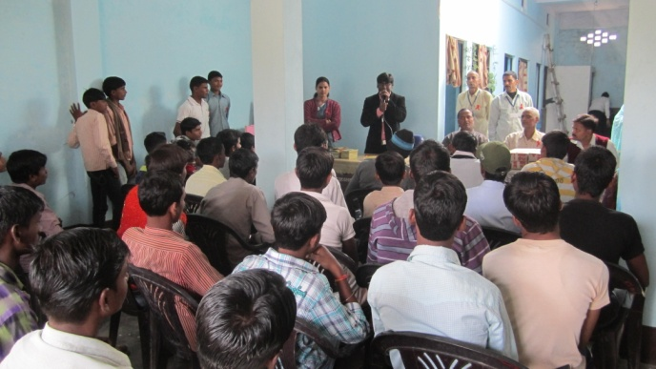 Institution has regularly organized such type of seminar to mobilize the public opinion against social evils and to reorient the existing institution and organization in order to prospect the instructs of needy, deprived and the poor.Topic- Cancer, Tuberculosis, AIDs day, Drugs Day, Disable day, NCF, Problem of child labour and Rural Awareness.

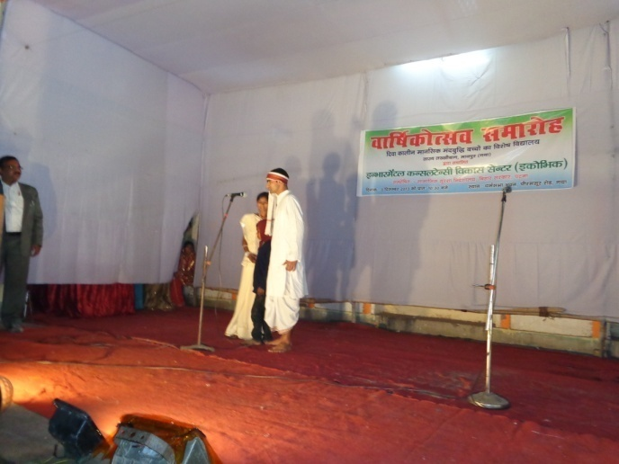

**Survey & Documentation**

The exhaustive baseline survey with questionaire was conducted for child labour School for NCLP, Patna and reproductive & child health and AIDs awareness among the residents of various district. Also for the street children,reason for their pathetic condition ,how their life style can be improved at Gaya, The Survey also carried out especially for disabled persons, HIV Positive Person, drug Addicts, and economically backward people in the state of Bihar. Survey conducted on socio – economic and education status for the propose of implementing development scheme for poverty alleviation, education & Health especially in rural area also.

**CONSUMER RIGHT**

Most of the people do not know about their rights and provision of consumer protection law. Our institution has taken the challenge to educate them about consumer rights. We organise seminars, exhibitions, rallies and workshops to sensitize consumers about their rights and responsibilities. The significant and important judgments from consumer forums IS distributed among people to make them aware on their rights as consumers.

**Communal Harmony**

|  |
| --- |
| India is a country of people with different religion, customs and belief, but there is a unity in diversity.  The essence of all religion is mutual brother-hood and love.  All religion Hindu, Muslim, Sikh and Christian etc. are all equal and teaches us knowledge of love as the humanity based on love and all religion gives the same message of love.  Our Organisation believes that the GOD is one and all the human beings are fruit of one tree.  Communal Harmony between the followers of the difference religion is very important and necessary for the overall development of our country.  ECOVIC has taken an initiative all over in the area of project to bring people together from different communities and religion through cultural program on different occasions for Communal Harmony and social integration . |

**ENVIRONMNTAL POLLUTION**

Environmental Education, Awareness and Training programmes plays a significant role in encouraging and enhancing people's participation

in activities aimed at conservation, protection and management of the environment, essential for achieving sustainable development.Our organization has taken care for environmental awareness among people. The Institution has organized a world environment day. Our Institution has organized essay and painting competition for children. To educate them and let them know the importance of greenery and unpolluted environment, therefore, is the priority of our organisation for the promotion of non-formal environment education and creation of awareness among all sections of the society through diverse activities using traditional and modern media of communication. The organization lunched a series of banners and poster in the city displaying needs for environment care, also organization is committed to save the environment through formal and non formal education programme.

Next step is the Plantation distribution programme, also organized from time to time in different parts of the districts of Bihar. In this programme nutritional plants are distributed and tree plantation by the road side in the districts where at least our different projects are carried out. A training programme is also organized how to adopt the new techniques for the agricultural work for the farmers in the respected place.

**DRS SYSTEM**

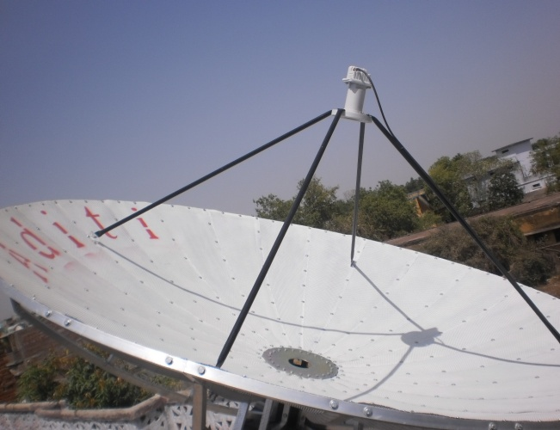DRS System was stalled at our centre with the collaborative effort of Rehabilitation Council of India, Govt. of India and Indra Gandhi National Open University. This system is benefited for the parents and trainees teacher. Parents of disabled child and trainees teacher getting the education/training in the field of disability/special education directly linked with the experts in the field of disability and get the opportunity to ask the question related to the child problem, education, therauptic management and rehabilitation.

**Manpower Development in field of Special Education**

The organization is running Dilploma in Education, Special Education, Mental Retardation { D.Ed SE (MR)} professional course in the field of Disability. The duration of the course is of two years. The examination is conducted by NIMH and course affiliated by

Rehabilitation Council of India, under MSJ &E, Govt. of India. This is our Fourth Batch completed successfully. Twenty five candidates passed in first class marks. We trained them the teaching Skills, Disabilities Management, Rehabilitation and Community Based Rehabilitation. In outreach programme teacher trainees are deputed to organize free checkup camp for identification of MR and HI children in district. The well established library with

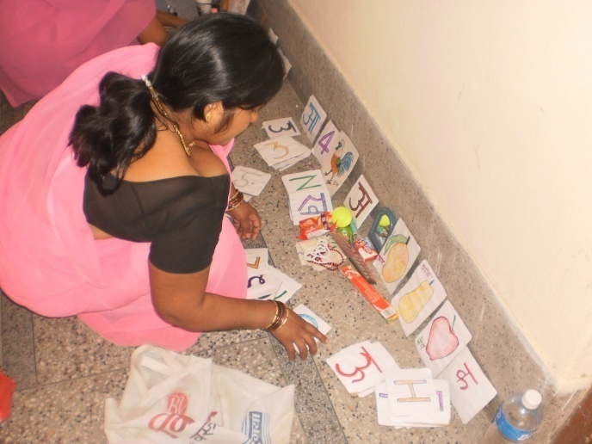

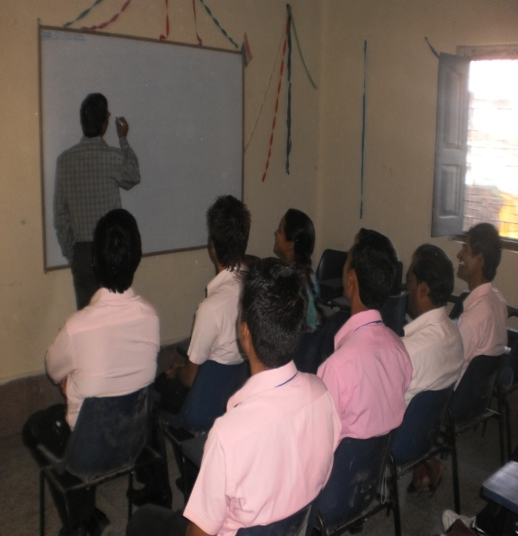

internet facilities is provided to the trainees teacher. They are getting trained to handle different types of assessment tools for subjective test and preparation of teaching learning materials to educate the disabled children

**CRE Programme**

Our organization has conducted the CRE programme on **Group Education Program** from **20th Nov. to 24th Nov 2013** at Gaya. The geographical area covered is different district of Bihar,Up and Jharkhand i-e. Banaras, Hazaribagh, Nawada ,Nalanda ,Aurangabad, Jamui , Patna ,Gaya, Lakhisarai,Ara and Purnia

The objective of CRE programme is to upgrade the knowledge and skills of in service and practicing Rehabilitation Professionals and personnel already registered with the RCI u/s 19 of the RCI Act of 1992.To update professional knowledge of master’s trainers working in the field of Rehabilitation and special Education. During the five days the following topics was covered;

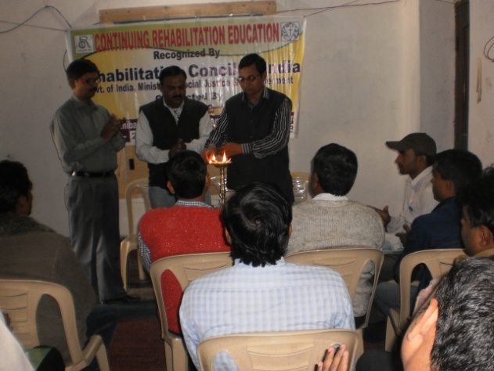

I)Introduction to small and large group.

ii) Diverse needs in a group

iii) Strategies in small and large group.

Iv) Cooperative learning.

v) Peer Tutoring.

Topics include the group work, presentation, Stimulation, workshop for preparation of TLM, group discussion, feedback and distribution of certificate. The topic was covered by the expert faculty of Psychology and Special Education. Total 26 special Educator working in the field of Mental Retarded has attended the

Continued Rehabilitation Education Programme from 20th Nov. to 24th Nov 2013 at our institute. The Schedule of the programme was 10 A.M to 5 P.M per day. The participants have good experience of the group because they are working in inclusive set up. They have enjoyed the five days training programme and good discussion panel was formed and every points was focus by the expert as well as participants. Printed material also distributed among the participants.

**Deewa Kalin Special School for Mentally Retarded Children**

**Sponsored by Directorate of Social Security**

This Pilot Project in Bihar was sponsored by Dept. of Social Security ,Govt. of Bihar was inaugurated on 3rd December 2013 by the then Gaya DM which we are running efficiently till now.

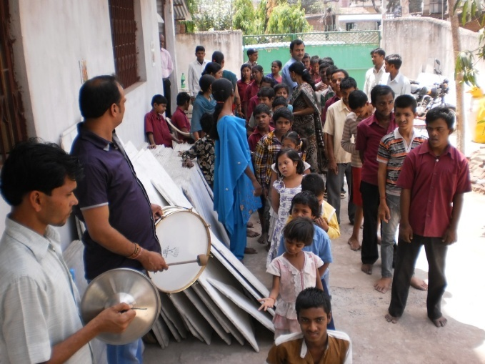

The school is fully equipped with all facilities like TLM, Variety of Toys, Computers, Library ,Vocational training, Recreational room etc. and to take care of these children we have trained teachers and staffs to train and guide them to day to day life skills and live normal life.

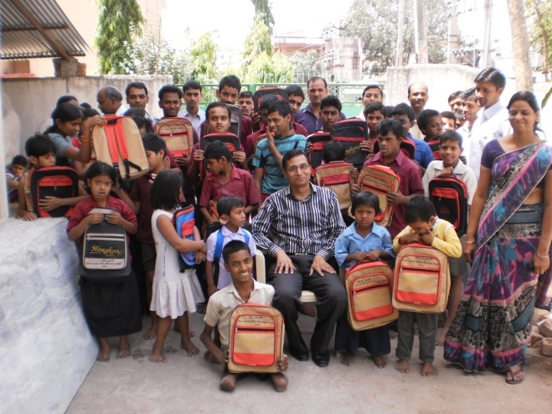

On the occasion of completion of one year our organization celebrated with a cultural programme on it own cost at Gaya where all the children of Deewa Kalin Special School for mentally retarded children participated.

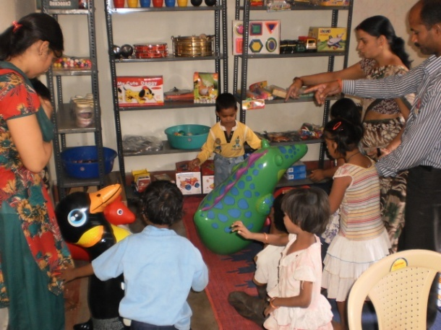

In this year 2014 , to mainstream the children of the school 25 children have been registered for

the Govt. Pension Scheme,also CRC Patna have been corresponded for the disability certificate for the rest of the children of the school

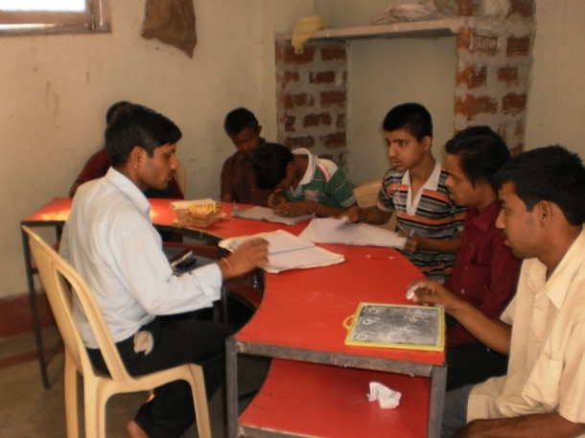

An Annual evaluation of all the children has been done and those found lagging behind a goal has been set for them by the teachers of the school and efforts are going on. In this special school we have divided the children in to different groups according to their IQ level and types of disability and also we utilize the natural method and structural method for their complete development.

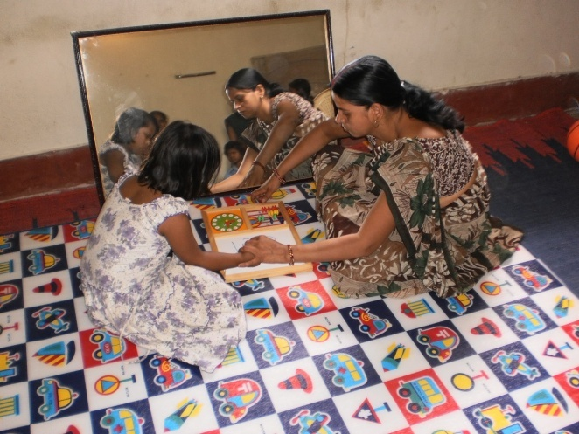

Children of Deewa Kalin MR Spl. School has been taken to many festive places to socialize them on many occasions this year.

During the year 2013-14 a proper counseling of both parents and children have been done and parents have been given proper instructions how to encourage their children to boost up their confidence.

Children are under proper guidance of trained Teachers from RCI Approved different universities and colleges.

Our organization has provided a vehicle free of cost for MR children to bring them to school and take them to their respective home. This facility of vehicle is a great relief for the parents and also for the children

Our main objective is to uplift the IQ level and make them self dependent so that they can be main streamed into our society and they should not be considered as a liability or burden to any one.

**OBSERVATION OF NATIONAL AND INTERARIONAL DAY**

Beside we have organized the following national and International Day.

**1. Republic Day 26th January**

**2. No Tobacco Day 31st May**

**3. Environmental Day 5th June**

**4. International Drug De-addiction Day 26th June**

**5. World Population Day 11th July**

**6. Independence Day 15th August**

**7. World Deaf Day 24th Sept.**

**8. World AIDS Day 1st Dec.**

**9. World Disable Day 3rd Dec.**

**10. Mental Retardation Day 8th Dec.**

**MONITORING AND SUPERVISION**

Monitoring and supervision is very essential elements of NGOs achievement but for the desired goal of success in all our project programme.

Monitoring of the project is done by getting each month instructions from inspecting officer during the progress of programme.

Inspecting Report Authorized Officially submit to persons to

Each month the authorized submit to report

Persons to management

The feed back is received etc, so as to enable our organization staff to ensure the attainment of sustainability. The society improvement is being observed with the performance of staff members.

**AUDITOR**

M/s D.Jha & Associates, Chartered Accountants, Patna conducted to audit for this year be decided by Annual General Meeting.